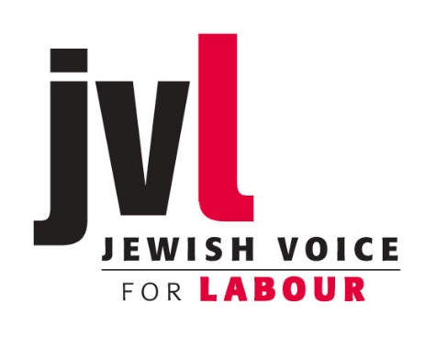 ADVICE ON RULE CHANGES

The Jewish Labour Movement (JLM) has been aggressively promoting a rule change that would facilitate a renewed campaign of suspensions based on fabricated antisemitism charges. There are other rule change proposals on the same topic. There is one from the NEC which may take precedence.

The existing rules can be downloaded from https://skwalker1964.files.wordpress.com/2017/03/rule-book-2017-labour.pdf

The impact of the proposed changes are spelt out here http://freespeechonisrael.org.uk/jlm-want-punish-thought-crime/

Jewish Voice for Labour’s advice to mandating meetings on proposed rule changes is three-fold:

1. If the JLM rule change (or variants of it from Folkstone & Hythe or Finchley & Golders Green) is moved:
Mandate to oppose
[Ref: Proposed amendment to CHAPTER 2 Clause I, Section 4 Membership Exclusions]

2. If the Hastings and Rye rule change motion comes to a vote:
Mandate to support
[Ref: Proposed amendment to CHAPTER 2 Clause I, Section 8 Conditions of membership]

3. Reports have indicated the NEC may propose a rule change on disciplinary process enabling it (the NEC) to establish a disciplinary code specifying the range of behaviours covered, to include antisemitic or racist statements and action. This would be uncontroversial if not for the danger that this could allow the discredited ‘IHRA working definition of ‘antisemitism’ in through the back door, including a set of examples which conflate antisemitism with criticism of Israel or Zionism (note the Labour Party Election Manifesto quotes only the 42 word definition, not the long list of examples). So:
Mandate to seek to ensure that any code of conduct will be subject to full consultation with the Party membership.
[n.b.: specific wording and section to be amended not yet available]

The threats posed by the IHRA definition are spelt out http://freespeechonisrael.org.uk/qcopinion/

